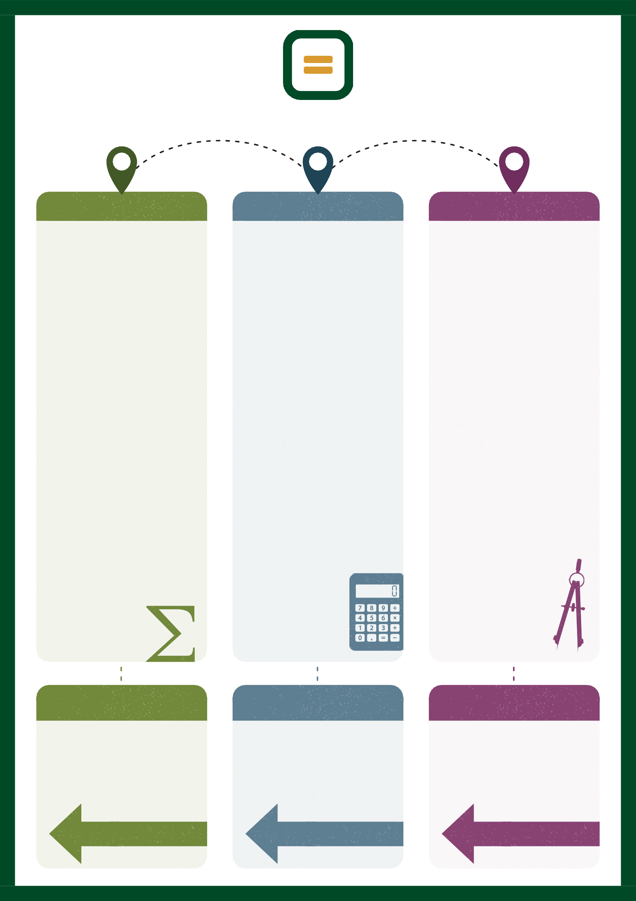

Year 10 Maths Learning Map

- T E R M 1 -
- T E R M 2 -
- T E R M 3 -

Algebraic Manipulation
Students develop algebraic fluency by expanding, factorising, simplifying expressions, and manipulating algebraic fractions. They apply these skills to solve increasingly complex mathematical problems.

Equations, Inequalities and Formulae
Students solve linear equations and inequalities, rearrange complex formulae, and apply algebraic methods to solve mathematical and real-life problems.

Quadratic Expressions and Equations
Students expand, factorise, and solve quadratic expressions and equations using a range of algebraic methods. They apply these techniques to solve mathematical problems.

Percentages
Students solve multi-step percentage problems, including compound growth, depreciation, and reverse percentages. They apply percentage calculations in financial and real-life contexts.

Ratio and Scale
Students solve problems involving ratio, scale drawings, and proportional reasoning. They apply these skills in a range of mathematical and real-life contexts.

Work with fractions
Students perform calculations involving numerical and algebraic fractions using efficient methods. They apply these skills to solve increasingly complex problems.

Non-Calculator Methods.
Students develop fluency in non-calculator techniques, including written methods and mental strategies. They apply these methods accurately and efficiently to solve mathematical problems.

Straight Line Graphs
Students interpret and construct straight-line graphs, calculating gradients and equations of lines. They use linear graphs to model and solve mathematical relationships.

Probability
Students calculate probabilities of combined events using diagrams and probability rules. They apply probability reasoning to solve increasingly complex problems.

Rounding and Estimation
Students use rounding and estimation to check calculations, calculate error intervals, and solve problems involving bounds. They apply these skills to assess the accuracy of solutions.

Perimeter, Area and Volume
Students calculate perimeter, area, surface area, and volume of increasingly complex shapes and solids. They apply these skills to solve geometric and real-life problems.

Interpret and Represent Data
Students represent, interpret, and compare statistical data using a range of diagrams and measures. They analyse data and draw justified conclusions.

Non-Linear Graphs
Students interpret, sketch, and analyse quadratic, cubic, reciprocal, and other non-linear graphs. They identify key features and use graphs to solve problems.

Angles
Students apply angle facts to increasingly complex geometric problems involving polygons, circles, parallel lines, and bearings. They justify their reasoning using mathematical arguments.

Graphs and Diagrams
Students interpret and construct a range of mathematical graphs and diagrams. They use graphical methods to analyse relationships and solve problems.

Vectors
Students represent, add, subtract, and interpret vectors in geometric contexts. They apply vector methods to solve problems and construct mathematical proofs.

Factors, Powers and Surds
Students develop fluency with factors, indices, powers, and surds, applying the laws of indices and simplifying surd expressions. They solve problems involving exact values.

Pythagoras’ Theorem and Trigonometry
Students apply Pythagoras' Theorem and trigonometric ratios to solve increasingly complex geometric problems. They use these techniques in mathematical and real-life contexts.

Simultaneous Equations
Students solve simultaneous equations using algebraic and graphical methods, including equations involving linear and quadratic relationships. They apply these techniques to solve mathematical problems.

Year 10 Summer builds on Year 9 by extending non-linear graphs, angle reasoning, and graphical methods to solve increasingly complex problems. Students deepen their understanding of vectors, factors, powers and surds, Pythagoras' Theorem, trigonometry, and simultaneous equations, providing a strong foundation for the final stages of GCSE mathematics.

Year 10 Spring builds on Year 9 by extending work on straight-line graphs, probability, and rounding and estimation, while developing geometric understanding through perimeter, area, and volume. Students also strengthen their statistical skills by interpreting and representing data to analyse information and draw justified conclusions.

Year 10 Autumn builds on Year 9 by developing algebraic manipulation, equations, inequalities, and quadratics into more advanced GCSE techniques. Students extend their understanding of percentages, ratio, fractions, and non-calculator methods, applying these skills to solve increasingly complex mathematical and real-life problems.

P R I O R L E A R N I N G
P R I O R L E A R N I N G
P R I O R L E A R N I N G

