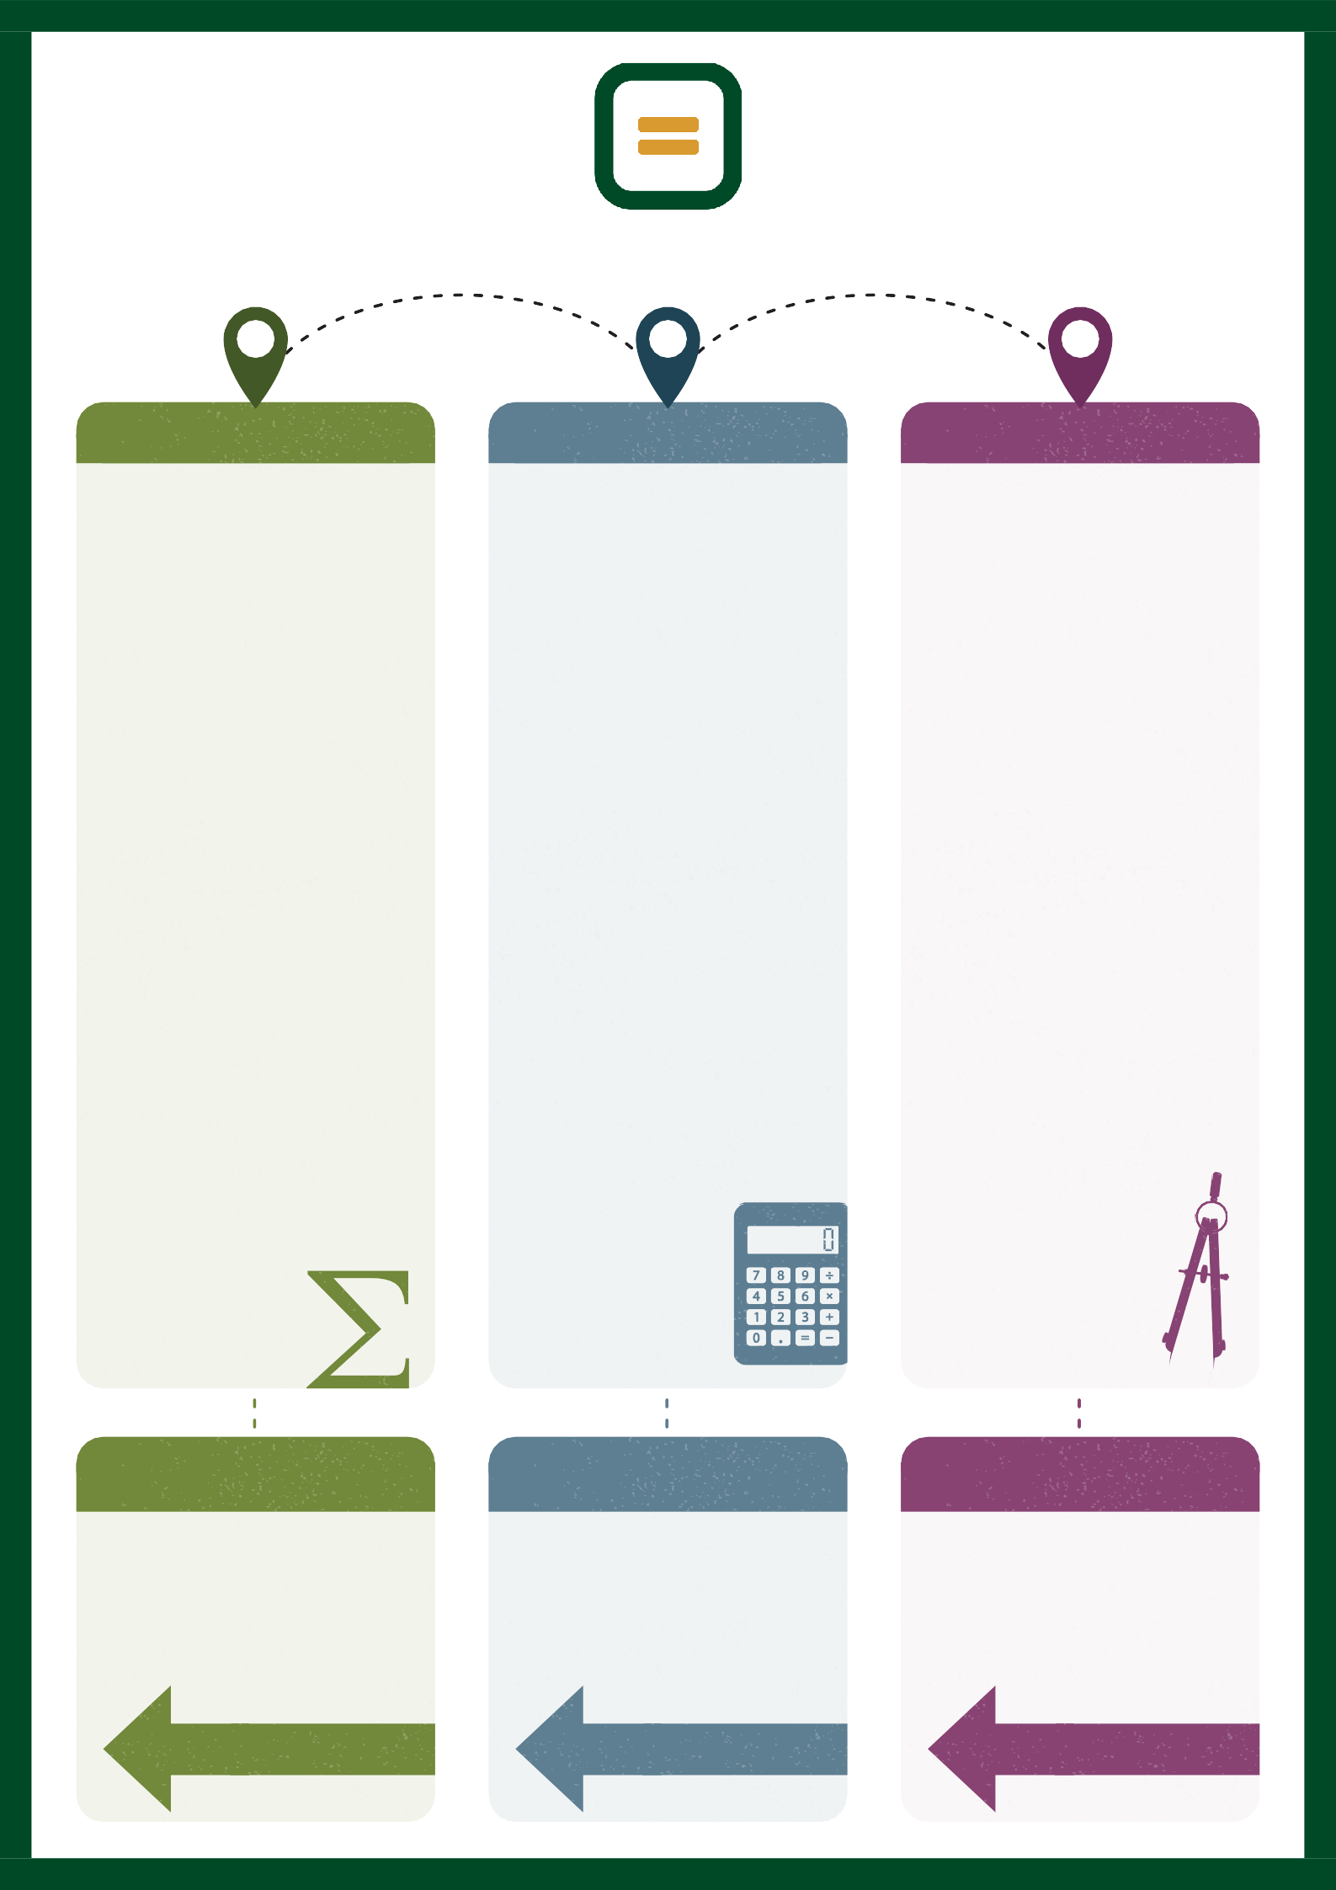

Year 11 (H) Maths Learning Map

- T E R M 1 -
- T E R M 2 -
- T E R M 3 -

Ratio and Proportion
Students solve problems involving ratio, proportion, and scale. They apply proportional reasoning in mathematical and real-life contexts.

Area and Volume
Students calculate the perimeter, area, surface area, and volume of a range of shapes and solids. They apply these skills to solve geometric problems.

Similarity and Congruence
Students apply the properties of similar and congruent shapes to solve geometric problems. They use scale factors and geometric reasoning to justify their solutions.

Sequences and Proof
Students generate and interpret linear and quadratic sequences and develop mathematical proofs. They apply algebraic reasoning to justify patterns and relationships.

Standard Form
Students perform calculations using numbers in standard form and apply these skills to solve problems involving very large and very small numbers.

Circle Theorems
Students apply circle theorems to calculate unknown angles and solve geometric problems. They justify their reasoning using deductive arguments.

Set Notation and Venn Diagrams
Students use set notation and Venn diagrams to represent information and solve probability problems. They apply logical reasoning to interpret relationships between sets.

Venn Diagrams
Students represent, add, subtract, and interpret vectors in geometric contexts. They apply vector methods to solve problems and construct mathematical proofs.

Year 11 Autumn builds on Year 10 by extending proportional reasoning, area and volume, and geometric reasoning through similarity and congruence. Students deepen their understanding of sequences, proof, standard form, circles, set notation, and Venn diagrams, applying these skills to increasingly complex GCSE problems.

P R I O R L E A R N I N G

Functions and Graphs
Students interpret, sketch, and analyse a range of functions and graphs. They use graphical methods to represent relationships and solve mathematical problems.

Equations and Formulae
Students solve increasingly complex equations, rearrange formulae, and apply algebraic methods to solve mathematical and real-life problems.

Rates
Students solve problems involving speed, density, pressure, and other compound measures. They apply proportional reasoning in a range of mathematical and real-life contexts.

Angles, Bearings and Trigonometry
Students apply angle facts, bearings, and trigonometric ratios to solve geometric problems. They use mathematical reasoning to solve increasingly complex situations.

Constructions and Loci
Students use ruler and compass constructions accurately and interpret loci in geometric contexts. They apply these skills to solve mathematical problems.

Transformations
Students perform and describe translations, reflections, rotations, and enlargements using accurate mathematical notation. They apply transformations to solve geometric problems and interpret relationships.

Year 11 Summer builds on learning from Years 7–11 by consolidating key mathematical knowledge and applying it in preparation for the GCSE examinations. Revision is informed by question level analysis from previous mock examinations, allowing targeted intervention on individual areas for development while revisiting high-frequency GCSE topics through retrieval practice, exam-style questions, and timed assessments to strengthen fluency, reasoning, and problem-solving.

P R I O R L E A R N I N G
Year 11 Spring builds on Year 10 by developing graphical methods, equations, and formulae to solve more challenging mathematical problems. Students extend their understanding of compound measures, angle reasoning, bearings, and trigonometry, applying these skills in a range of geometric and real-life contexts.

P R I O R L E A R N I N G

Exam Preparations and Revision
Students consolidate their mathematical knowledge through a structured programme of GCSE examination preparation. Revision is informed by question level analysis from previous mock examinations, enabling targeted intervention on individual areas of weakness while revisiting high-frequency GCSE topics. Students develop fluency, reasoning and problem-solving through regular retrieval practice, exam-style questions, repeated exposure to exam style questions and completion of timed assessments to build confidence and maximise examination performance.

