
Year 8 Maths Learning Map

- T E R M 1 -
- T E R M 2 -
- T E R M 3 -

Ratio
Students develop their understanding of ratio by simplifying, sharing quantities in a given ratio, and solving ratio problems in a range of mathematical and real-life contexts.

Proportion and Scale
Students explore direct proportion and scale, using scale factors to enlarge shapes, interpret scale drawings, and solve problems involving proportional reasoning.

Algebraic Manipulation
Students develop algebraic fluency by expanding brackets, factorising expressions, simplifying algebra, and solving increasingly complex equations.

Coordinates and Graphs
Students plot and interpret coordinates in all four quadrants, draw and interpret linear graphs, and use graphs to represent and solve mathematical relationships.

Multiply and Divide Fractions
Students multiply and divide fractions, including mixed numbers, using efficient methods. They apply these skills to solve problems in a range of mathematical contexts.

Symmetry and Reflections
Students identify lines of symmetry, recognise rotational symmetry, and reflect shapes accurately in horizontal, vertical, and diagonal mirror lines on a coordinate grid.

.
Area, Volume and Density
Students calculate the area and volume of a range of shapes and solids, and use density to solve problems involving mass and volume in mathematical and real-life contexts.

Equations and Inequalities
Students solve increasingly complex equations and inequalities using algebraic methods. They represent solutions accurately and apply these skills to solve mathematical problems.

Percentages
Students calculate percentages of amounts, percentage increase and decrease, and solve problems involving percentage change. They apply these skills in a range of mathematical and real-life contexts.

Indices
Students develop their understanding of index notation by applying the laws of indices, working with powers and roots, and simplifying numerical expressions.

Standard Form
Students write, interpret, and calculate with numbers in standard form. They apply standard form to represent very large and very small numbers accurately and efficiently.

Interpret and Represent Data
Students represent and interpret data using a range of statistical diagrams. They compare data sets, analyse distributions, and draw informed conclusions from statistical information.
Angles in parallel lines and polygons
Students apply angle facts to parallel lines and polygons, calculating missing angles using geometric reasoning and justifying their methods.

Tables and probability
Students use tables and sample spaces to calculate probabilities of single and combined events. They interpret outcomes and apply probability reasoning to solve problems.

Circles
Students explore the properties of circles, including radius, diameter, circumference, and area. They solve problems involving circles using appropriate formulae and units.

Graphs and Charts
Students construct, interpret, and compare a range of graphs and charts. They analyse data, identify trends, and draw justified conclusions from statistical information.

Sequences
Students recognise, describe, and generate linear and non-linear sequences. They use algebraic rules to find terms and make predictions about patterns.

.

Year 8 Summer builds on Year 7 by extending angle facts to include parallel lines and more complex polygon problems, developing probability from simple outcomes to using tables and sample spaces, and applying knowledge of graphs and data to interpret a wider range of charts. Students also build on sequence work by exploring algebraic rules for linear and non-linear sequences before consolidating key mathematical knowledge and skills from across Year 8 through revision and problem solving.

P R I O R L E A R N I N G
P R I O R L E A R N I N G

Year 8 Autumn builds on Year 7 by extending ratio and proportional reasoning into more complex contexts, developing algebra from notation and simple equations to manipulation and factorisation, and progressing from plotting coordinates to interpreting linear graphs. Students also build on fraction calculations by multiplying and dividing fractions and develop geometric reasoning through symmetry and transformations.

P R I O R L E A R N I N G

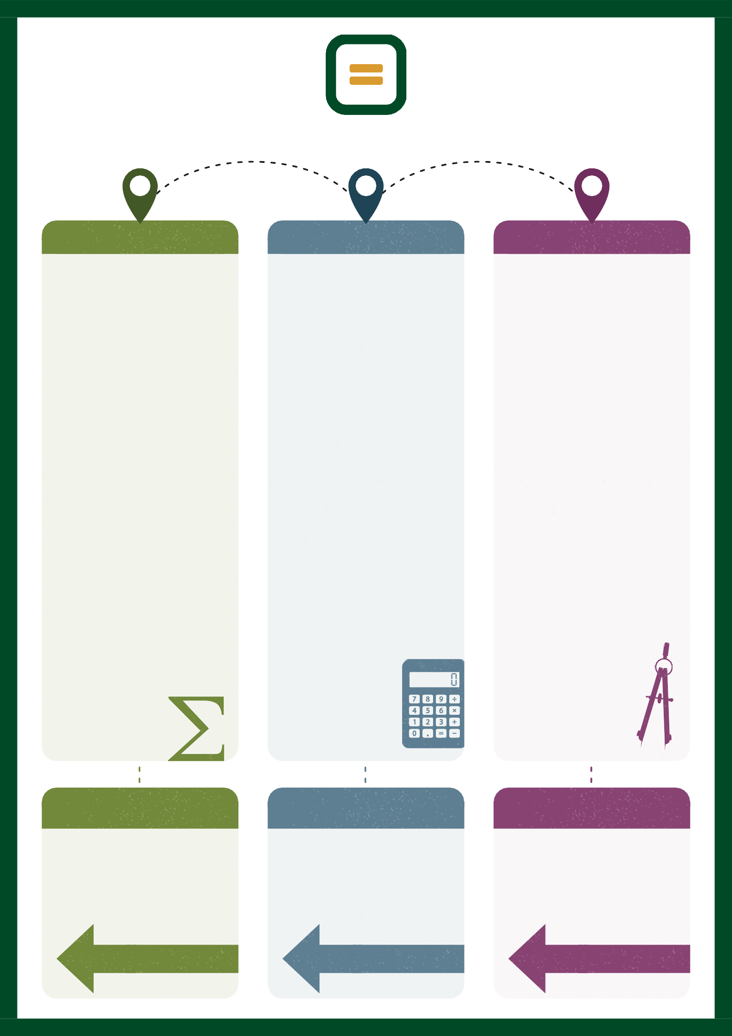
Year 8 Spring builds on Year 7 by extending work on perimeter and area to include volume and density, developing algebra from solving equations to solving inequalities, and broadening understanding of percentages to include percentage change and reverse percentages. Students also deepen their understanding of indices and apply standard form to represent very large and very small numbers, while extending data handling to interpret and compare statistical information.

